- MANAGER ID SEQUENCE
CREATE SEQUENCE COMP_MGR_ID
INCREMENT BY 1
START WITH 1
MAXVALUE 100
NOCACHE
NOCYCLE;
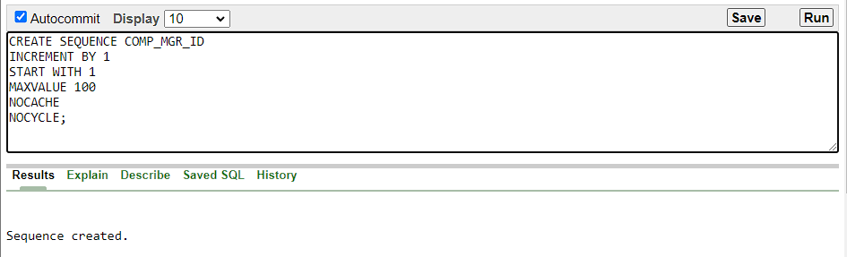

2.PHONE ID SEQUENCE
CREATE SEQUENCE PHONE_PHN_ID
INCREMENT BY 1
START WITH 1
MAXVALUE 100
NOCACHE
NOCYCLE;

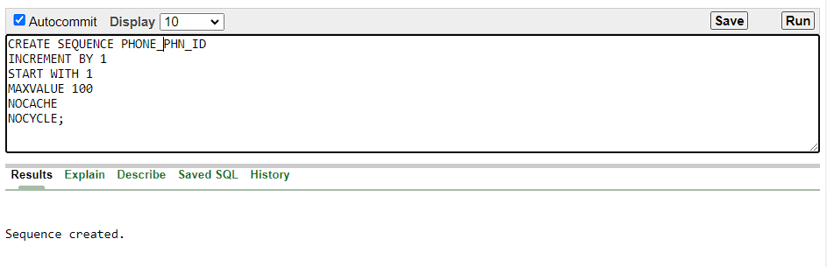
3.SELLER ID SEQUENCE
CREATE SEQUENCE SELLER_SLR_ID
INCREMENT BY 1
START WITH 1
MAXVALUE 100
NOCACHE
NOCYCLE;
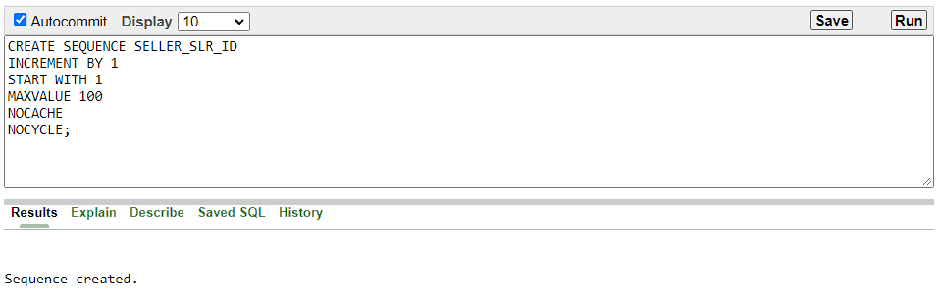
4.CUSTOMER ID SEQUENCE
CREATE SEQUENCE CUSTOMER_CUS_ID
INCREMENT BY 1
START WITH 1
MAXVALUE 100
NOCACHE
NOCYCLE;
